**“Show Me That Cat!” Website**

**Project Description:**

This is going to be a website called “Show Me That Cat!”. It is going to be a website where you can scroll and see all different sorts of cats. You will be able to sort them by varying filters. There will be a form that the user will fill out. On this form the user will add the cat’s name, cat’s age, cat’s sex, cat’s breed, a photo of the cat, and some varying traits that they can choose for their cats. Once this form is filled out and is submitted, their cat will be added to the database where other users can scroll through the website and see the cats. Some of the filters that you can sort through will be by sex, age, breed, specific traits, etc.   
  
 For now, only the website admin will be able to edit or delete information after it is submitted. I would prefer to be able to make a little *passcode* system for users to be able to add a passcode, maybe add a *hint* field too optionally, and that way once they type in the passcode, they themselves can edit or delete their own submissions, but for some reason if this seems to be too complicated for me, a website admin will be my fallback.   
  
 For the adding of a cat, there will be a button that is selected that will send you to a separate web page to fill out the form. (image below with rough draft look). For the updating of a cat, I am going to send the user to a web page that is pretty much the same form, with the header changed from *add cat* to *update cat*, and the information pre-populated now instead of the blank form like when you are adding a cat.

**Database Description:**

I decided to use Excel to plan out my tables. I chose to color code my field names that are being referenced in numerous tables, it helped me piece together my tables and stay organized. So far, I have 9 tables. I have never taken an SQL class or did any database work before this class, so I really hope I have a good understanding of how the tables should be working!   
  
 *cat_info*, *traits_category*, and *assigned_traits* will be the tables that are used for user display (after the form is submitted). I will be having visuals under the **UI Description** to give an idea of what I would like each table to do.

The next two pages are the table ideas that I came up with. This is pretty much all the information for all the tables that I am intending to use with table names and field names. I also decided to show some examples of the tables being populated using my 3 cats as an example.

I noted that *cat_info* does not have a paragraph next to the table like the other tables do. This table is going to be the *primary* table where all the keys from different tables will be referenced regarding information about the cat (excluding traits, that is handled elsewhere). I want the ability to allow users to upload photos, so I am not sure exactly how to do that but I added it as a table field name just so my intention is shown for it. I am not sure if I am adding it properly. I believe I read that in the table, the image location will be stored but I have not researched it that much yet.

I am also not sure if I am storing passcodes properly, but I read it was good to add the passcodes to its own designated table for security reasons, so I hope I am implementing that properly!

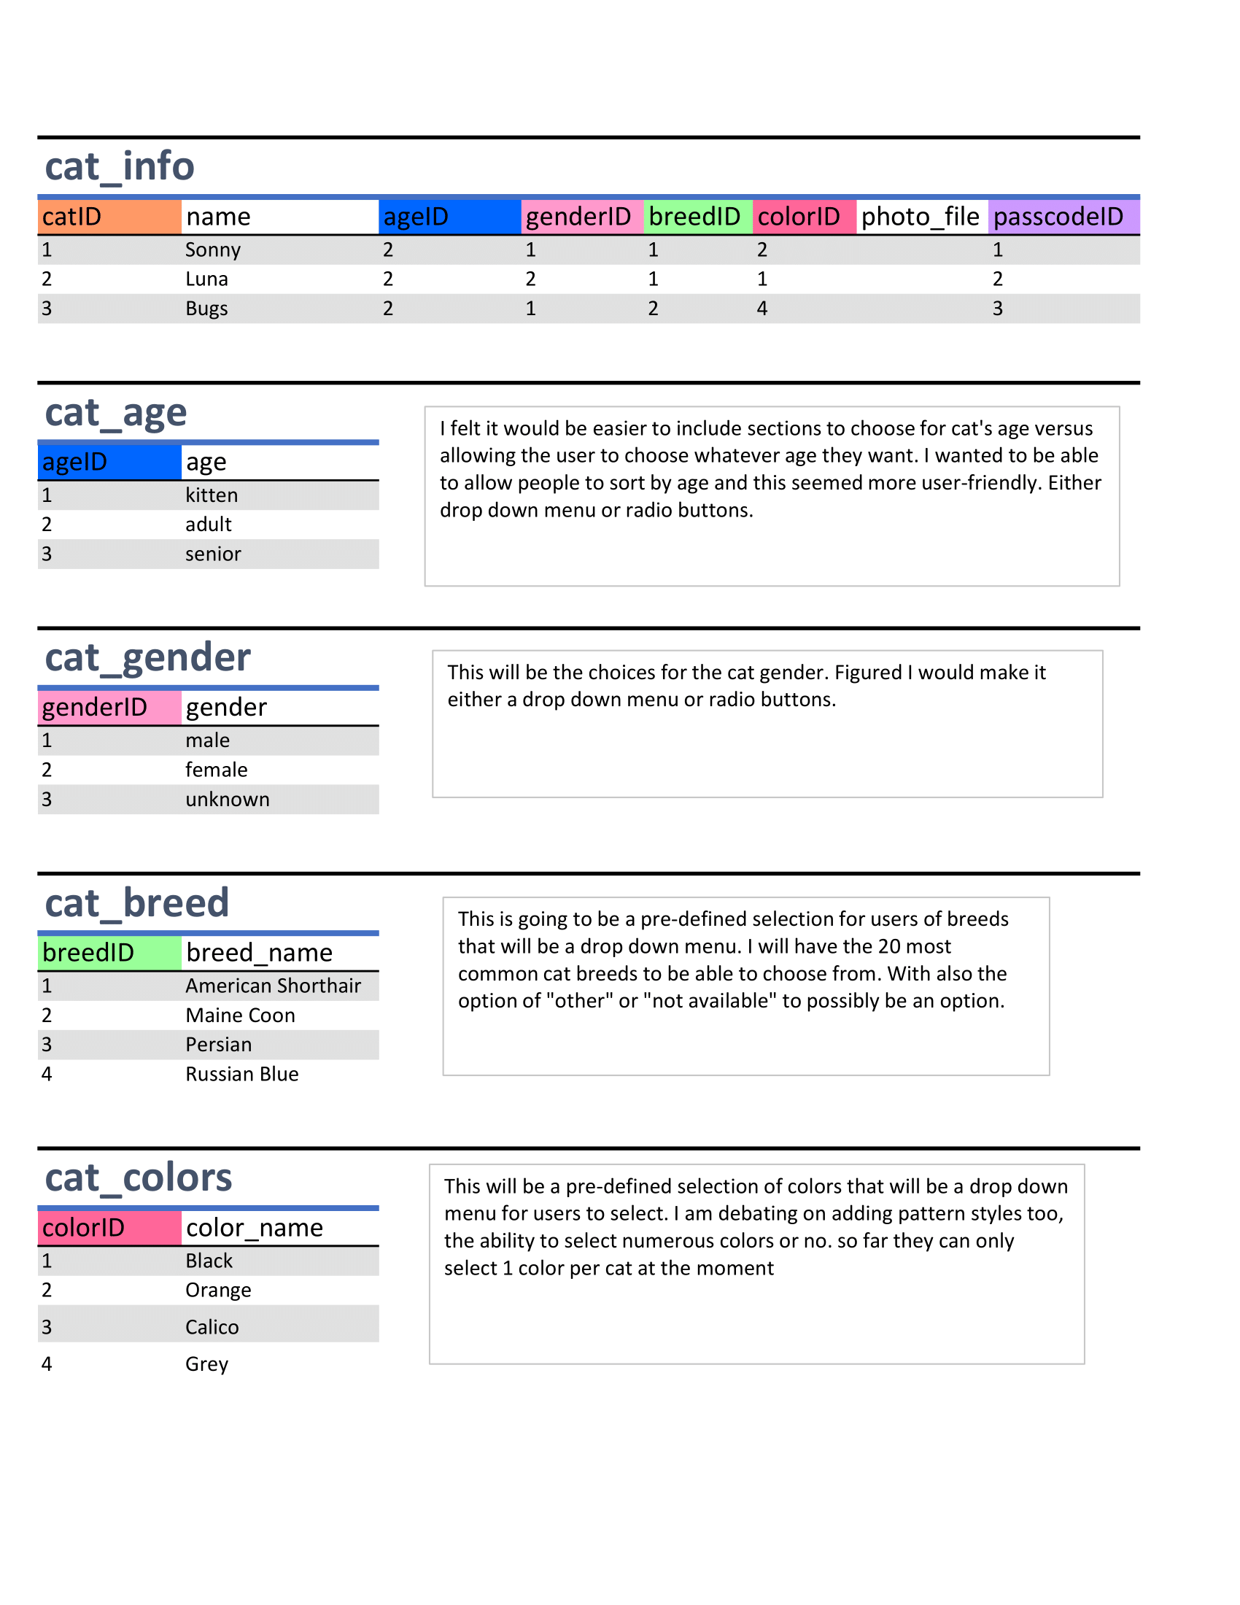

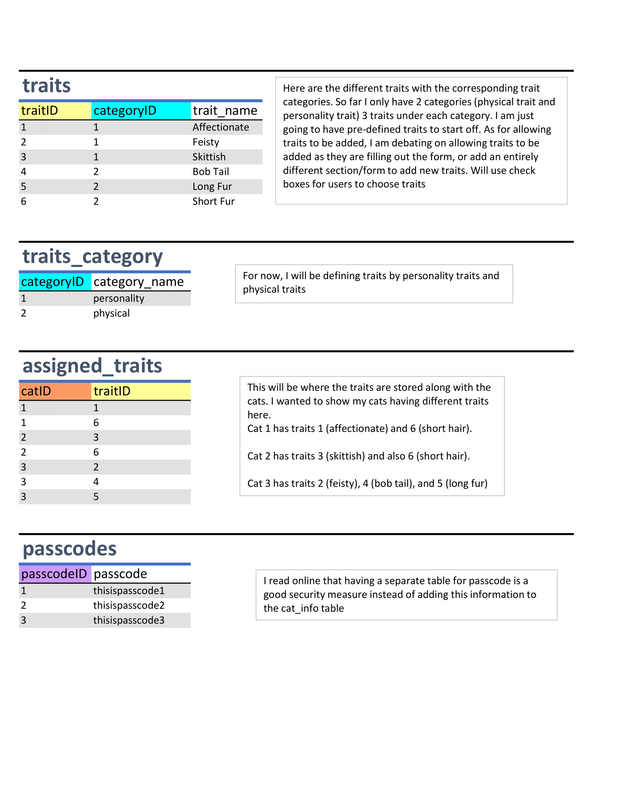

**UI Description:**

In the next 3 pages, I have some quick mock-ups I made using Figma. The main page will be the page where the cat images are sitting. I want the cat images to look like little index cards on the screen. I want their name to populate the space under the image inside the card. The images will sit in a grid like format.

When you click the hamburger symbol on the top right, I want a menu to open that allows users to access the *add new cat* button and gives users the ability to sort and filter out the images to the left. I would like users to be able to sort using various things such as based on traits, on breeds, colors, gender, whatever they would like.

When you click on one of the cards with the cat images, it will lead to a new page that displays all the cat’s information such as breed, age, personality traits chosen, etc. I have a trash can and a pencil icon on both the card images and the page displaying cat information which, if you know the passcode for that cat, will allow you to update or delete the cat information.   
  
For updating a cat form, I am figuring I will just use the exact same form for adding a cat, but making sure the information is pre-populated based on the cat that was chosen.

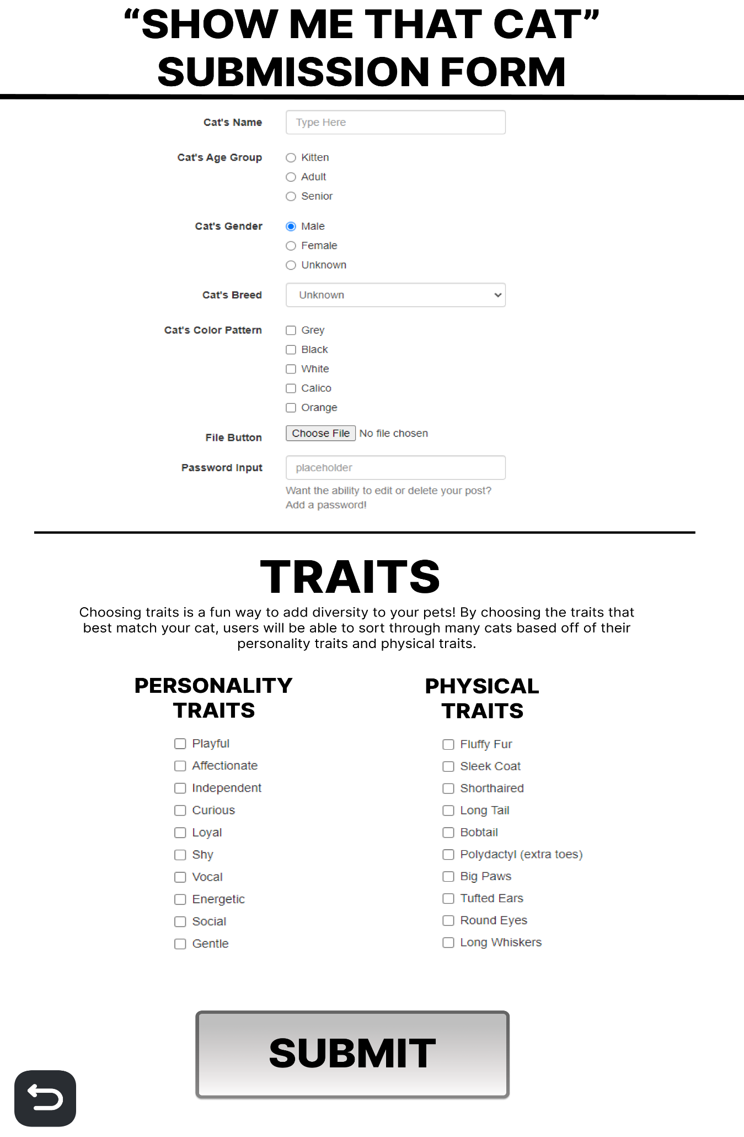

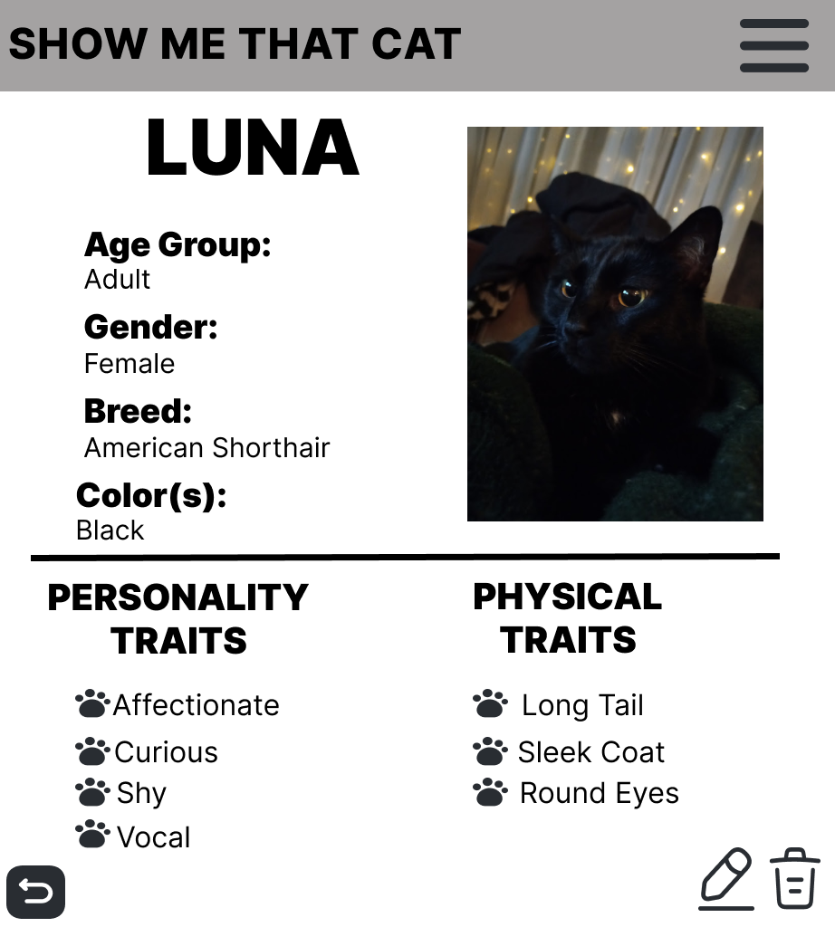**CSS Description:**

Below I have some color themes I am debating between. The first 2 are my preferred color themes, with the black and pink one being my top pick for the moment, but very well might use the blue theme instead. If I have time, maybe I will allow people to choose between different themes and just use all of them instead  
  
 I wanted to use a fun font like *Short Stack* for the names under the images on the main screen because I feel it gives it an old school bulletin board where you see pictures with people’s hand-written names on there. This website is a fun and cute idea, so I wanted to use fonts that are fun but also readable. I wanted to use a big blocky font like *Lolita One* for the header font to give the title of the page some umph with its title, to make it look large and bold.   
  
 I would like there to be some hover animations over the cards with images like enlarging the card and maybe rotating it a couple degrees when you hover. Clicking on the cards is how you can see the full image of the cat.   
  
 I would like to use some fun icons like the paw prints in the photos above, but we will see if that works easily, it will not be a main priority.